Muniza Aslam

WMA-373068

ASSIGMENT NO 2 QUESTION NO 1

<!DOCTYPE html>

<html lang="en">

<head>

    <meta charset="UTF-8">

    <meta name="viewport" content="width=device-width, initial-scale=1.0">

    <title>Document</title>

    <style>

        table tr,th,td{

            border: 1px solid burlywood;

        }

    </style>

    <style>

        tabel{

            width: 50;

        }

    </style>

</head>

<body style="text-align: center;">

    <h2>HTML rowspan Attribut</h2>

    <table>

        <tr>

<th>Name</th>

<th>Age</th>

        </tr>

        <tr>

<td>Ajay</td>

<td rowspan=2>24</td>

        </tr>

<tr>

<td>Priya</td>

</tr>

    </table>

</body>

</html>

<br>

<br>

<br>

<br>

<table>

<tr>

<th>Sno</th>

<th>Fruit Name</th>

<th>Quantity</th>

</tr>

<tr>

<td>1</td>

<td>Orange</td>

<td>60</td>

</tr>

<tr>

<td>2</td>

<td>Mango</td>

<td>50</td>

</tr>

<tr>

<td>3</td>

<td>Pineapple</td>

<td>30</td>

</tr>

</table>

<br>

<br>

<br>

<table>

<style>

table{

width: 50%;

border-collapse: collapse;

text-align: center;

}

th,td{

border: 1pX solid black;

padding: 8PX;

}

th{

    background-color: lightgray;

}

</style>

</table>

<table>

<tr>

<th rowspan="2">Customer</th>

<th colspan="3">Item</th>

<th colspan="3">Payments</th>

</tr>

<tr>

    <th >item</th>

    <th>Qty</th>

    <th>Price</th>

    <th>Date</th>

    <th>Amount</th>

    </tr>

<tr>

    <td rowspan="3">customer 1</td>

<td>item1</td>

<td>5</td>

<td>$400.00</td>

<td>12 Sep 2018</td>

<td>$3,000.00</td>

</tr>

<tr>

<td>item2</td>

<td>10</td>

<td>$200.00</td>

<td rowspan="2">18 Sep 2018</td>

</tr>

<tr>

    <td>item 3</td>

    <td>2</td>

    <td>5,000.00</td>

    <td>$2,000.00</td>

</tr>

<tr>

<td rowspan="2">Customer2</td>

<td>item4</td>

<td>5</td>

<td>$600.00</td>

<td>20Sep2018</td>

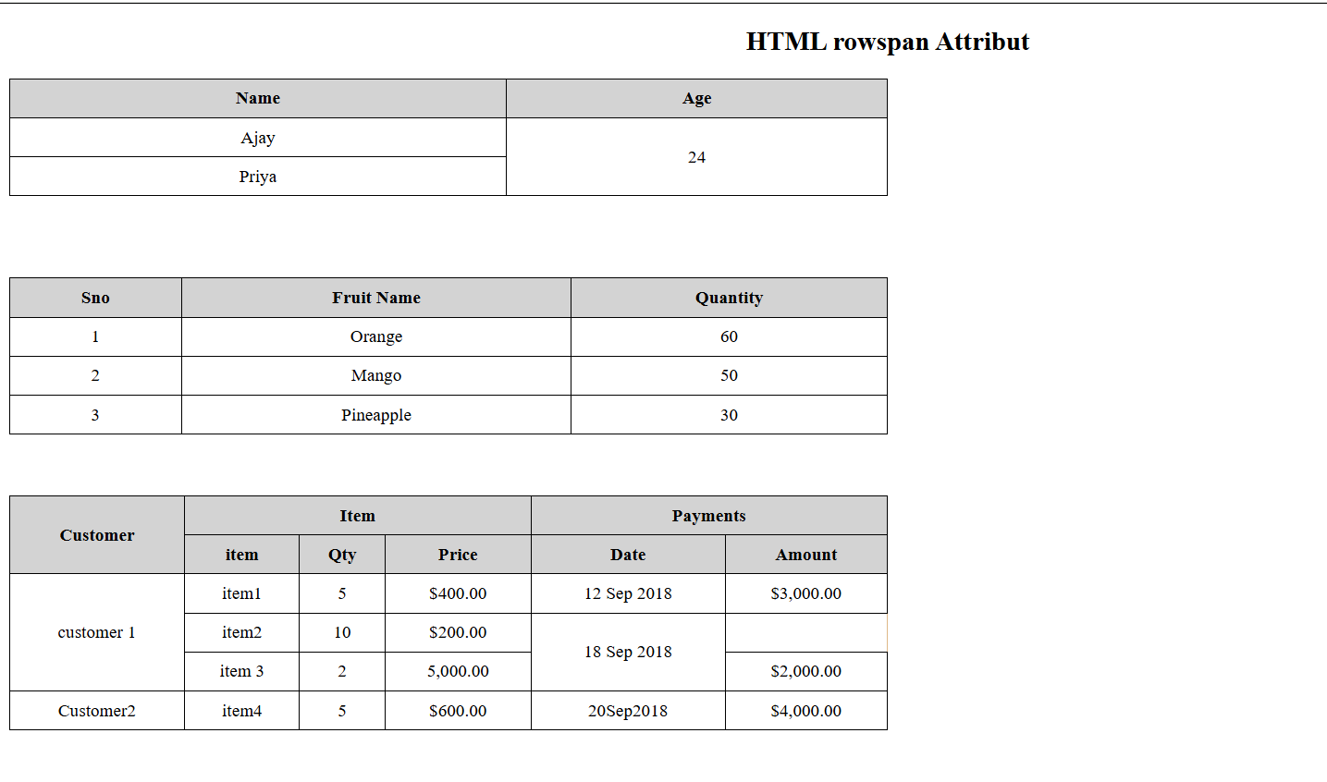

QUESTION NO 2

<!DOCTYPE html>

<html lang="en">

<head>

    <meta charset="UTF-8">

    <meta name="viewport" content="width=device-width, initial-scale=1.0">

    <title>Document</title>

    <style>

table tr,th,td{

border: 1px solid burlywood;

}

    </style>

</head>

<body>

    <table>

        <h2>Student Records</h2>

<tr>

<th>No</th>

<th>Image</th>

<th>First Name</th>

<th>Last Name</th>

<th>Age</th>

<th>Hobby</th>

</tr>

<tr>

<td>1</td>

<td><img src="https://encrypted-tbn0.gstatic.com/images?q=tbn:ANd9GcTuAwNHiJFbioBC-TjnYAoqh1C2KoqOqwfang&s" alt="" width="100" height="100"></td>

<td>Jams</td>

<td>Forsty</td>

<td>25</td>

<td><a href="https://www.google.com/search?q=swimming&sca_esv=bd">Swimming</a></td>

</tr>

    <tr>

<td>2</td>

<td><img src="https://img.lovepik.com/element/40128/5316.png_1200.png" alt="" width="100" height="100"></td>

<td>Anna</td>

<td>Bayo</td>

<td>23</td>

<td><a href="https://www.google.com/search?q=cooking&oq=cooki&gs_">Cooking</a></td>

    </tr>

    <tr>

        <td>3</td>

        <td><img src="https://img.freepik.com/free-photo/portrait-man-cartoon-style_23-2151133939.jpg"  alt="" width="100" height="100"></td>

        <td>James</td>

        <td>Lartey</td>

        <td>22</td>

        <td><a href="https://www.google.com/search?q=rapping&sca_">Rapping</a></td>

    </tr>

    </table>

</body>

</html>

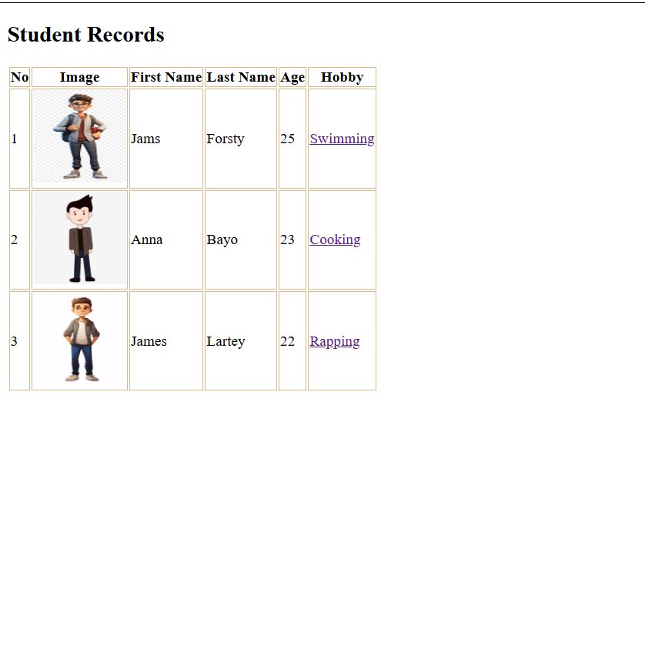

QUESTION NO 3, TABLE 1

<!DOCTYPE html>

<html lang="en">

<head>

    <meta charset="UTF-8">

    <meta name="viewport" content="width=device-width, initial-scale=1.0">

    <title>Document</title>

    <style>

table tr,th,td{

    border: 1px solid burlywood;

}

    </style>

</head>

<body>

<h2>Table</h2>

<Table border="1"

Summary="This table gives some statistics about fruit files: average height and

 weight, and percentage with red eyes (for both males and females).">

 <caption><Em>A test table with merged cells</Em></caption>

 <tr>

    <th rowspan="2"><th colspan="2">Average<th rowspan="2">Red <br>eyes

</tr>

<tr>

<th>height<th>wight

</tr>

<tr>

<th>Males<TD>1.9<TD>0.003<TD>40%</th>

<tr><th>Female<TD>1.7<TD>0.002<TD>43%</th>

</body>

</html>

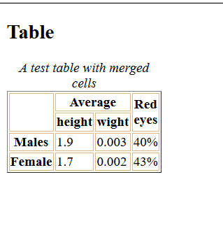QUESTION NO 4,TABLE 2

<!DOCTYPE html>

<html lang="en">

<head>

    <meta charset="UTF-8">

    <meta name="viewport" content="width=device-width, initial-scale=1.0">

    <title>Document</title>

    <style>

table tr,th,td{

    border: 1px solid burlywood;

}

    </style>

</head>

<body>

    <table>

<tr>

<th>No</th>

<th>Full Name</th>

<th>Position</th>

<th>Salary</th>

<th>Type</th>

</tr>

<tr>

<td>1</td>

<td>Bill Gades</td>

<td>Founder Microsoft</td>

<td>$1000</td>

<td rowspan="4">Company Founder</td>

</tr>

<tr>

<td>2</tdSteve>

<td>Steve Jobs</td>

<td>Founder Apple</td>

<td>$1200</td>

<tr>

<td>3</td>

<td>Larry Page</td>

<td>Founder Google</td>

<td>$1100</td>

</tr>

<tr>

    <td>4</td>

    <td>Mark Zackeberg</td>

    <td>Founder Facebook</td>

    <td>$1300</td>

</tr>

<tr>

<td colspan="3">Total Expens</td>

<td>$4600</td>

</tr>

</tr>

    </table>

</body>

</html>

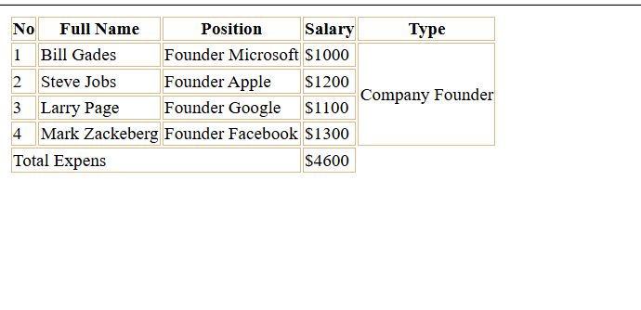

QUESTION 3 (TABLE)

<!DOCTYPE html>

<html lang="en">

<head>

    <meta charset="UTF-8">

    <meta name="viewport" content="width=device-width, initial-scale=1.0">

    <title>Document</title>

    <style>

table tr,th,td{

    border: 1px solid burlywood;

}

    </style>

</head>

<body>

    <table>

<tr>

<th style="background-color: aqua;">Device</th>

<th style="background-color: aqua;">Brand</th>

<th style="background-color: aqua;">Specifications</th>

</tr>

<tr>

<td>SmartPhone</td>

<td>Apple</td>

<td>

    <table border="1">

</tr>

<th style="background-color: yellow"> MODEL</th>

<TH style="background-color: yellow">Storege</TH>

</tr>

<tr>

<td>iPhone 12 Pro</td>

<td>256GB</td>

</tr>

<tr>

<td>iPhone SE</tdiPhone>

<td>128GB</td>

</tr>

    </table>

    <tr>

<td>Laptop</td>

<td>HP</td>

<td>15.6" Display</td>

    </tr>

    <tr>

<td>Table</td>

<td>Sumsung</td>X

<td>10.5"Display</td>

    </tr>

</body>

</html>

<!DOCTYPE html>

<html lang="en">

<head>

    <meta charset="UTF-8">

    <meta name="viewport" content="width=device-width, initial-scale=1.0">

    <title>Document</title>

    <style>

table tr,th,td{

    border: 1px solid burlywood;

}

    </style>

</head>

<body>

    <table>

<tr>

<th style="background-color: aqua;">Device</th>

<th style="background-color: aqua;">Brand</th>

<th style="background-color: aqua;">Specifications V </th>

</tr>

<tr>

<td>SmartPhone</td>

<td>Apple</td>

<td>

    <table border="1">

</tr>

<th style="background-color: yellow"> MODEL</th>

<TH style="background-color: yellow">Storege</TH>

</tr>

<tr>

<td>iPhone 12 Pro</td>

<td>256GB</td>

</tr>

<tr>

<td>iPhone SE</tdiPhone>

<td>128GB</td>

</tr>

    </table>

    <tr>

<td>Laptop</td>

<td>HP</td>

<td>15.6" Display</td>

    </tr>

    <tr>

<td>Table</td>

<td>Sumsung</td>

<td>10.5"Display</td>

    </tr>

</body>

</html>

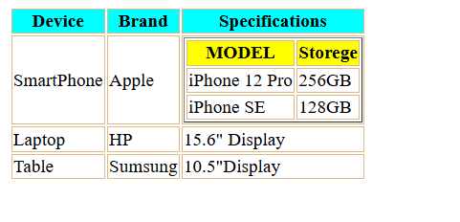

QUESTION NO 4 (FORM)

<!DOCTYPE html>

<html lang="en">

<head>

    <meta charset="UTF-8">

    <meta name="viewport" content="width=device-width, initial-scale=1.0">

    <title>Document</title>

</head>

<body>

    <form action="">

        <h1>Registration Form</h1>

<label>First Name:

<input type="text" maxlength="20" size="50" placeholder="Enter First Name">

</label>

<br>

<label>Last Name:

<input type="text" maxlength="20" size="50" placeholder="Enter Last Name">

</label>

<br>

<label>Email:

<input type="email" size="50" placeholder="Enter Email Address">

</label>

<br>

<label>Password:

<input type="password" maxlength="20" size="50">

</label>

<br>

<label>Gender: <br>

    Male

    <input type="radio" name="gender" value="Male">

</label>

<br>

<label>

    Female

    <input type="radio" name="gender" checked>

</label>

<br>

<label>

    other

    <input type="radio" name="gender" value="other">

</label><br>

<label>Age:

<input type="number" maxlength="20" size="50">

</label>

<br>

<label>

    Preferences:

</label>

 <br>

<label>Acrylic Painting

<input type="checkbox">

</label>

<br>

<label>Oil Painting

    <input type="checkbox">

</label>

<br>

<label>Water Color Painting

<input type="checkbox">

</label>

<br>

<label>Select Occupation

</label>

<select name="student" id="student">

    <option value="">Student</option>

    <option value="">Teacher</option>

    <option value="">Docter</option>

</select>

<br>

<label>Bio</label> <textarea rows="7" cols="40">Share Few Line about Yourself...</textarea>

<br>

<label>

<input type="reset">

</label>

<button>SUBMIT</button>

    </form>

</body>

</html>

